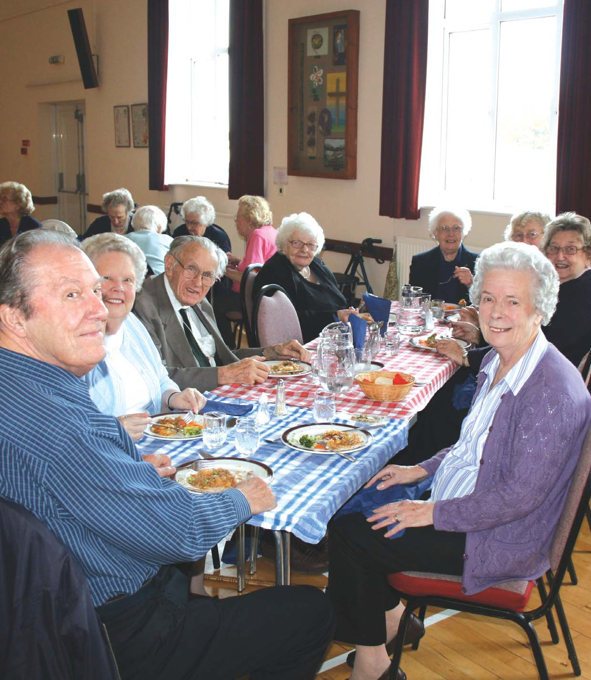

Come dine with us
Managing Food Safety for Voluntary
Lunch Clubs

Introduction
As a volunteer who takes an active part in organising and running a lunch club of which there are many around the county, you provide a vital service to residents, offering them good food, company and something to look forward to.
However, catering for large numbers can be daunting, especially in relation to food safety – but it needn’t be. This booklet aims to take the fear out of food hygiene and if the advice is followed it will give you peace of mind.
When preparing food for other people it is really important that all steps necessary are taken by you, to make sure that the food you produce for guests attending the lunch clubs has been prepared, stored and served hygienically. After all, if you were eating out, you would want to know that any food you were going to eat was safe.

How to use this booklet
The contents of this booklet have been laid out under a series of headings to systematically take you through the whole process of preparing food for others. There is a section about the records you must keep so that you can show you have been following this guidance and are keeping within the law.

Buying food
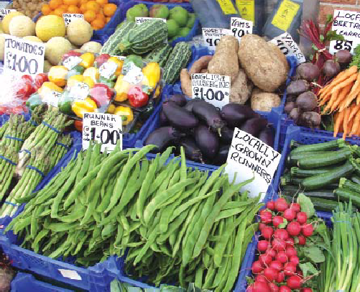

The lunch club supervisor should appoint a person(s) to be responsible for purchasing the food from reputable shops and supermarkets.
When buying the food, it should be checked to ensure that it looks right, the wrapping/packaging isn’t damaged and also that it is within the date marking. All pre-packed foods come with a date indication on the label, these are either ‘use-by’ or ‘best before’ dates.
Use-by dates: are found on ‘high-risk foods’, these could cause food poisoning i.e. those that:
- Are ready to eat ■ Are moist
- Are high in protein ■ Require chilling
- Have a short shelf life
These foods will include cooked meat, fish, dairy products, cook chill foods etc.
By exceeding the ‘use-by’ date, such foods have exceeded the critical time limit within which the product might be considered safe. It is a criminal offence to sell food past its use-by date.
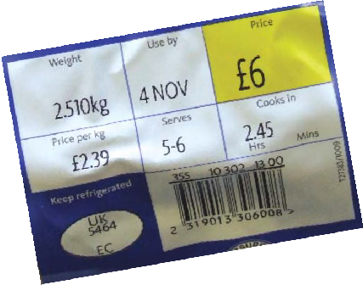

‘Best before’ dates: usually appear on canned, dried and frozen products. This is a quality guideline. In other words, foods that have past their ‘Best Before’ dates, may not be as crispy, tasty or look as good as the manufacturers intended.

Taking the food home
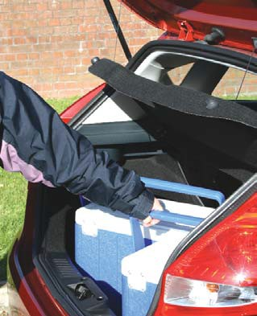

All chilled and frozen foods should be transported in clean, insulated containers or cool bags if needed, the journey home should take as little time as possible, less than an hour. When you arrive home the chilled and frozen foods should be stored in the refrigerator and freezer immediately.

Storing food safely
You should check your refrigerator temperature daily to make sure that food is stored below 8ºC for legal purposes, but the preferred temperature range is between 1-4ºC.
Ideally, you should store raw and ready to eat foods in separate fridges, if they are in the same fridge then raw meat should be stored below ready to eat food. Make sure that all foods are covered; this will help prevent harmful bacteria spreading from raw foods to ready to eat foods.
Your fridge should be kept clean and tidy, and you should always make sure that all food is within its date markings.
Any part used tins of food should be decanted into a suitable container and covered.
Never put any hot or warm food into the fridge, this will increase the temperature and cause condensation, making the fridge an ideal place for
bacteria to grow.
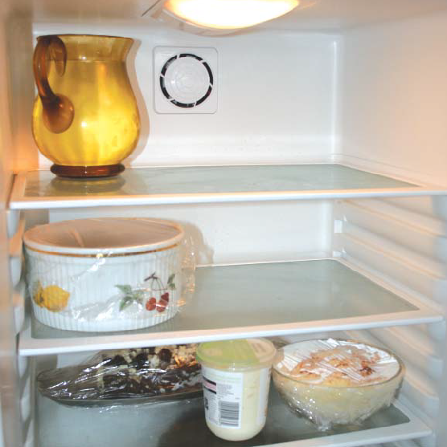

You should check your freezer temperature daily to make sure that food is stored at -18ºC or below.
Different foods should be segregated and ensure that all foods are wrapped, labelled and dated correctly.
If defrosting food prior to cooking, then ensure that it is defrosted in the fridge for as long as is necessary. It should be covered and stored at the bottom of the fridge to prevent contamination of other foods. Make sure that the food is fully defrosted prior to cooking. Check that the food is pliable and that there are no longer any ice crystals within the food.

Avoiding contamination

Cross contamination is one of the most common causes of food poisoning. It happens when harmful bacteria are spread onto food from other food, worktops, hands, equipment or utensils. These harmful bacteria often come from raw meat, poultry and eggs. Other sources of bacteria include people, pests, pets, soil on vegetables and waste bins.
Here are some points to follow to avoid contamination:
- Always cover food.
- Wash your hands often (see personal hygiene).
- Make sure that you store food correctly – always store raw meat at the bottom of the fridge and cooked/ready to eat foods above.
- Use disposable dishcloths if possible and change them regularly. If using reusable cloths, ensure they are laundered after each day.
- Preferably use disposable paper roll to dry up. If using tea cloths, ensure they are changed regularly throughout the day.
- Ensure that all the kitchen utensils and chopping boards are properly cleaned and disinfected after each use. It is good practice to have separate colour coded chopping boards for raw meat, raw vegetables and ready to eat foods.
- Clean and disinfect all hand and food contact surfaces regularly.
- Never allow pets in the kitchen when preparing food.
- Wipe down all work surfaces in the kitchen/hall before you start to prepare and or serve the food.
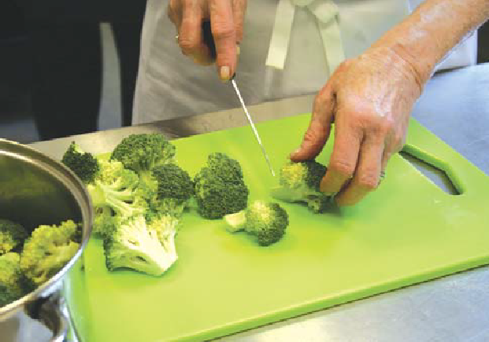

Food also needs protecting from ‘chemical contamination’ – this is where chemicals get into food, for example, cleaning products.
Make sure you store all cleaning products in a cupboard away from food. When you are
cleaning, ensure that all food has been put away.
‘Physical contamination’ is when objects get into food that shouldn’t be there, these objects
commonly include hair, broken glass, fingernails and jewellery – ensure that all food is covered to prevent anything from falling into the food.
It is important for you to know what to do if you are preparing food for someone who has a food allergy. Here are some points to follow:
- Always check if people attending the lunch club have any food allergies. This information must be passed onto everyone who is involved with the purchasing, storage and preparation of food for the lunch club. It is a good idea to have the details documented in a place for all the lunch club volunteers to see.
- Make sure that you check all ingredients of any meals being prepared for a person with a food allergy, if someone has a severe allergy, they can react to even a tiny amount of the food they are sensitive to.

Allergen guidance when cooking for Community or Donating Food
As you are registered as a food business, you are required to provide information about allergens present in the food you prepare. It is recommended that you provide details of the relevant 14 allergens as best practice. This will allow people with food allergies to make safe food choices.
The 14 allergens are: celery, cereals containing gluten (such as barley and oats), crustaceans (such as prawns, crab and lobsters), eggs, fish, lupin, milk, molluscs (such as mussels and oysters), mustard, peanuts, sesame seed, soybeans, sulphur dioxide and sulphites (at a concentration of more than ten parts per million) and tree nuts (such as almonds, hazelnuts, walnuts, brazil nuts, cashew, pecans, pistachios and macadamia nuts).
If you know the people that you are cooking for, ask about any allergy requirements they may have before preparing their meals.
If you are cooking for a community group, you can provide allergen information by labelling food containers, using a recipe card or menu matrix or providing a note for each meal.
Cooking for someone with a food allergy or intolerance can be worrying if you’re not used to doing it. You can plan a safe meal by:
- Asking what they can and can’t eat.
- Making sure you keep allergens separate from other foods to avid cross-contamination.
- Double-checking the ingredients lists on prepacked foods of allergens information.
- Checking the ingredients with the person who provided the food if it was donated.
- Avoiding adding topping or garnishes to dishes which might otherwise appear allergen-free.
- Cleaning work surfaces and equipment thoroughly to remove traces of anything you might have cooked before.
There are often good substitutes available for ingredients that someone may need to avoid. Don’t hesitate to ask for help and suggestions for ingredients form those with a food allergy that you are cooking for.

Personal hygiene
It is important to follow good personal hygiene to help prevent bacteria from spreading to food. The following rules are regarded as good practice and should be followed:
  - Avoid touching your face or nose or coughing and sneezing over food.
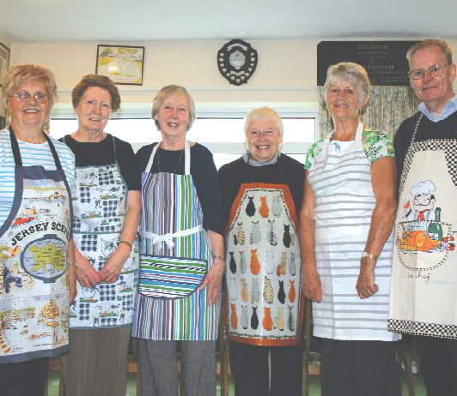

  - Ideally you should not wear jewellery when preparing food except a plain wedding band. Watches and jewellery can collect and spread dirt and harmful bacteria and they can fall into the food.
  - Make sure your clothes are clean, and wear a clean apron when preparing food.
  - Fingernails should be kept clean and short; nail varnish must not be worn, and false fingernails are not allowed, as they could fall off into the food.
- Cuts and sores should be completely covered with a waterproof dressing, ideally a brightly coloured one.
- Hair must be clean and if long tied back.
- Do not prepare any food if you have diarrhoea and or vomiting as people suffering from these symptoms often carry harmful bacteria on their hands and can spread them onto food and the equipment they touch. Please tell your supervisor if you are ill. Do not prepare food until you have been symptomless for at least 48 hours.
Harmful bacteria can spread very easily from hands to food, work surfaces and equipment around the kitchen. You should always wash your hands properly before preparing food or touching ready to eat foods.
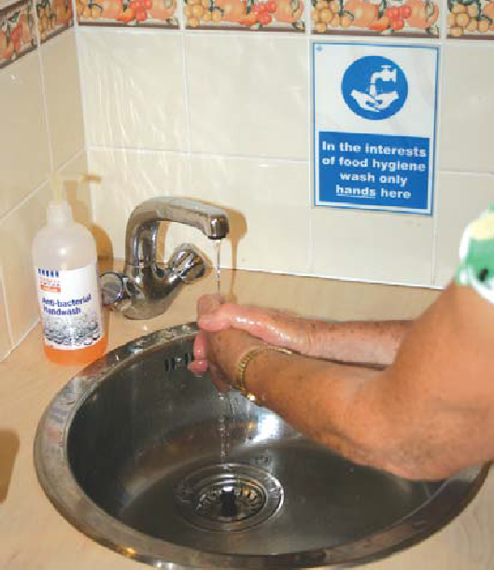

You should always wash your hands after:
- Visiting the toilet
- Touching raw meat /poultry/eggs
- Emptying bins
- Cleaning
- Touching a cut or changing a dressing
- After blowing your nose, coughing into the hand etc.
- After smoking
- After handling rubbish and waste food
You should always wash your hands before:
- Starting work in the kitchen
- Handling food
The law says that anyone preparing food must receive training in food safety. Generally volunteers who prepare the lunches have many year’s experience of cooking, however it is always a good idea to have refresher training as things change from time to time. If you would like some training please contact your environmental health department who may be able to assist. Alternatively online courses for the volunteers will demonstrate that they have the appropriate level of food knowledge.

Cooking and cooling
Proper cooking kills food poisoning bacteria such as Salmonella, E.coli O157, Listeria and Campylobacter. It is important that foods are cooked thoroughly, and the target temperature is achieved throughout. Undercooking will enable bacteria to survive.
The most important point is not to assume food is thoroughly cooked – you must actively check – cooking is nearly always a ‘critical control point’ in food safety – that is, if food is not cooked thoroughly, it is likely to be unsafe.
When you cook food, you must always check that the food is cooked thoroughly. The core (centre) or the thickest part of the food should reach a temperature of at least 70ºC for 2 minutes or 75ºC for at least 30 seconds. The best method of checking food temperatures is by using a probe thermometer – which must be properly cleaned and disinfected between uses to ensure it does not cause contamination of different foods. If you do not have a probe thermometer you can check that juices run clear and that the food is steaming hot. To aid cooking, stirring and turning products around in the oven can be useful.
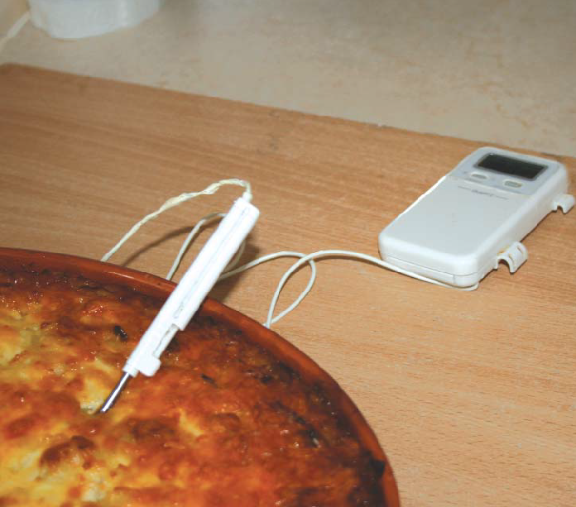

When the food is cooked it should be eaten as soon as possible, however, it may be necessary to store it for a short time prior to eating. If this is necessary, it should be stored in an oven, hot cupboard or hot trolley or something to keep it above 63ºC, if stored for more than 2 hours.
Wherever possible do not cook, cool, store and re-heat food. Cook and serve is always the safest method because if food is not re-heated thoroughly bacteria can survive and then multiply. However, in the event that you do need to cook and re-heat, you must ensure that after the initial cooking, the food is cooled as quickly as possible in a cooler part of the kitchen, and always within one-and-a-half hours and then stored in the fridge. When you re- heat food you must ensure that it reaches a core temperature of at least 70ºC for two minutes
or 75ºC for at least 30 seconds.
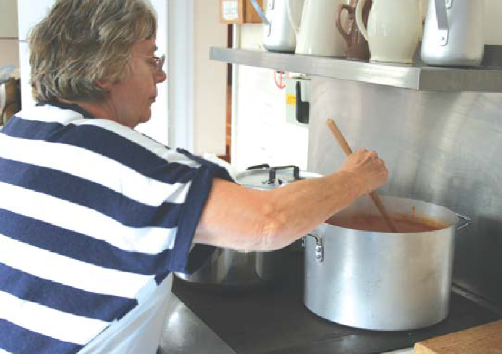

If you have any food left over from the lunch club, it should be disposed of immediately. It should not be given or sold for people to take home, nor should it be saved and used as ingredients in other dishes. This is because you have taken every practical step to ensure the food is safe to eat and if others take the food home you will have no control over what happens to the food in the future.

Cleaning
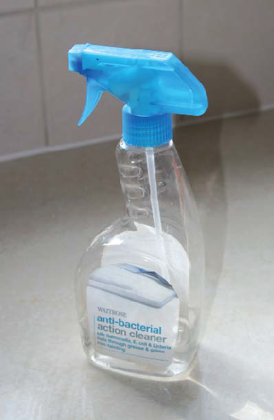

It is essential to keep your kitchen and equipment clean to get rid of harmful bacteria and stop them spreading. It is important to clean everything in a kitchen, but particular attention should be paid to food and hand contact surfaces, for example:
- Chopping boards
- Taps
- Switches
- Knives and utensils
- Fridge door handles
- Work surfaces
You must always make sure that all food equipment is cleaned
and disinfected before use and in-between different tasks and handling different types of food, especially raw food. You can do this by using a chemical or using a dishwasher.
To clean and disinfect work surfaces you will need a clean cloth, hot water, detergent and a food safe disinfectant, or alternatively use a sanitiser, this will remove any dirt and grease and also disinfect, which means that bacteria will be reduced to safe levels. We advise that sanitisers meet the BSEN 1276 or BSEN 13697 standards. This is usually on the label of the bottle, along with contact time. To wipe down the surfaces after cleaning them, use some disposable paper towels.
Clear and clean as you go:
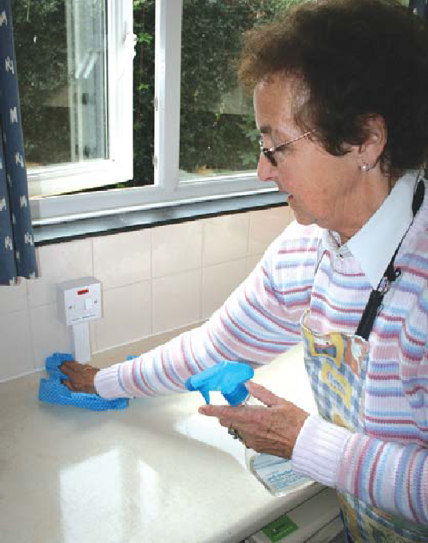

- Clear away any used equipment that is no longer required, ensure it is cleaned and in good condition
- Clear away any food as soon as possible
- Clean work surfaces thoroughly after each use
- If you make a mess, then clean it up immediately
- Keep your kitchen in a tidy condition and remove any unnecessary clutter
- Always remember to empty your bin regularly as rubbish provides ideal conditions for bacterial growth.

Pest control
Check your kitchen regularly for any signs of pests for example in your food cupboards, as pests can carry harmful bacteria. Make sure no food is left out at night. Avoid having windows and doors open whilst preparing food so as not to allow flies into your kitchen. If you ever notice a problem, call your local authority or a pest control contractor immediately.

Transporting food
It is always better to cook and serve on site. However, if food is prepared at home, then it must be transported to the venue as quickly as possible, in well-covered, clean containers and using cool bags/boxes if needed. All food needs to be transferred to appropriate storage on arrival at the venue.
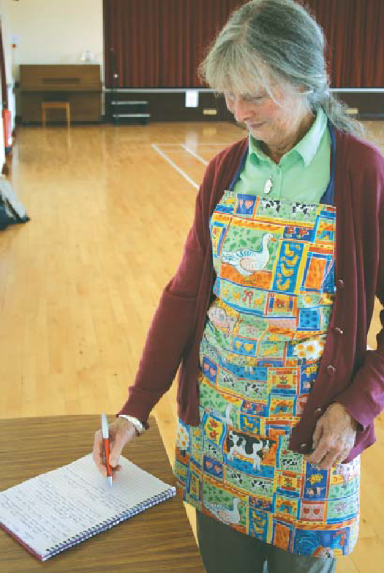

Keeping on top of things
Throughout this document time and temperature control has been mentioned many times, the key to food safety, other than cleanliness is to cut out the amount of time that food ‘hangs’ around for and ensure that food is kept very cold (in the fridge or freezer) or very hot, so bacteria will not multiply.
The law says that you must be able to show that all food you provide for other people is safe to eat; this can be achieved if you follow the basic points covered in this document.
We have designed a checklist for you to fill in, which is on the next page. You will need to read through the checklist and complete the sections that are applicable to you. Upon completion you should ensure that you always follow the safe working practices listed, this will show that you are keeping within the law. You will need
to amend the checklist if you make any changes to the practices and procedures you follow. If you are unsure about anything, then you must seek clarification from your supervisor and discuss any problems you have encountered.
There is a separate checklist for the supervisors to pull everything together, which must be completed on each lunch club day.

Managing Food Safety for Voluntary Lunch Clubs
Name of Food Handler ..................................................................................................................
Signature ........................................................................................................................................
Name of Lunch Club ......................................................................................................................
I carry out the following task /s for the lunch club: (Tick ✓as appropriate) I buy the food
I store the food at my house

I prepare the food at my house

I transport the food to the lunch club

Please tick the boxes to confirm that you carry out this practice. Provide any additional information which may help describe what you do more accurately.

Buying Food
I buy food from reputable shops and supermarkets.
I always check to ensure that food looks good, the wrapping isn’t damaged and the food is within the date markings.
I transport the food in clean, insulated containers or cool bags if needed, the journey home is less than an hour.

Storing Chilled Food Safely
All chilled foods are put in the fridge immediately after bringing them home and my fridge is always kept clean and tidy.
I check my fridge temperature daily to make sure it is between 1-4ºC.
All the food in my fridge is covered and within its date marking and I always segregate raw and ready to eat foods in my fridge.

Storing Frozen Food Safely
All frozen foods are kept frozen solid at
-18ºC or below.
I ensure that all frozen food is wrapped, labelled and within its date marking.
My freezer is always kept clean and tidy.
Tick ✓ Additional Information
....................................................................

....................................................................

....................................................................

....................................................................

....................................................................

....................................................................

....................................................................

....................................................................

....................................................................

Avoiding Contamination
I always prepare raw and ready-to-eat foods separately, using separate equipment and keep them covered and separate when stored.
I always wash my hands between different tasks.
I never allow my pets into the kitchen when preparing food for the lunch club.
I am aware of people with special diets and so do not use any ingredients that are allergens for them.

Personal Hygiene
I always wash my hands thoroughly before handling food and in-between different tasks.
I wear a clean apron when I prepare food.
I always follow good personal hygiene practices.
I have attended a food hygiene awareness course.

Cooking & Cooling
I always check food to ensure it is cooked thoroughly.
I always make sure that the food I prepare and cook is within its date marking.
Once cooked I either keep food hot or I cool it within one-and-a-half hours. I then keep it cool during any storage or transportation.

Cleaning
I always clean and disinfect equipment, utensils and all hand and food contact surfaces before use and between different foods and activities.
I use a clean dishcloth daily and when I use tea towels I change them regularly throughout the day.
I store my cleaning products in a cupboard away from food and I always make sure that food is put away prior to cleaning.
I always clear and clean as I go.

Pest Control
I check my kitchen regularly for any signs of pests.
If I ever find any problems I call a contractor immediately.

Transporting Food to the Lunch Club
The interior of the vehicle used is clean.
All food is covered and in clean containers. The food is transported as quickly as possible.
The food is transferred to appropriate storage on arrival.
Tick ✓ Additional Information
....................................................................

....................................................................

....................................................................

....................................................................

....................................................................

....................................................................

....................................................................

....................................................................

....................................................................

....................................................................

....................................................................

....................................................................

....................................................................

....................................................................

....................................................................

....................................................................

....................................................................

....................................................................

....................................................................

....................................................................

....................................................................

Cheltenham Borough Council, Municipal Offices, Promenade, Cheltenham, GL50 9SA.
Tel: 01242 264135
Email: envhealth@cheltenham.gov.uk



We would like to acknowledge Wealden District Council in the production of this pack.

