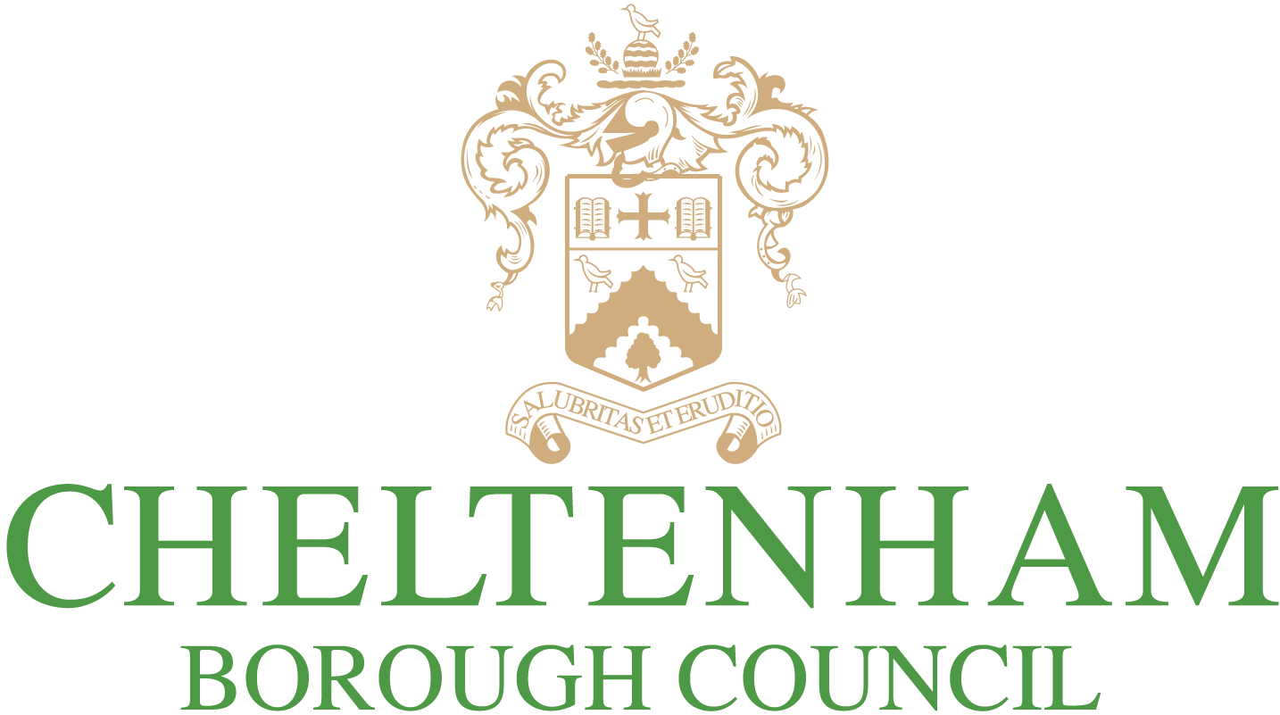

Caravan Sites and Control of Development Act 1960 as amended by

the Mobile Homes Act 2013

Application for Variation of a Caravan Site Licence

Please complete and submit your form to: privatesectorhousing@cheltenham.gov.uk
or post to: Private Sector Housing, Cheltenham Borough Council, Municipal Offices, Promenade, Cheltenham, GL50 9SA

SITE LICENCE NUMBER
SITE NAME
SITE ADDRESS
POST CODE |  | TEL. No.

LICENCE HOLDER
NAME
ADDRESS
POST CODE |  | TEL. No.
EMAIL

MANAGER
(if different from above)
NAME
ADDRESS
POST CODE |  | TEL. No.
EMAIL

DETAILS OF VARIATION REQUESTED

Please provide all information relating to the nature of the variation requested and the reasons for variation. Attach copies of any relevant documentation e.g. site licence conditions, site plan, planning permission, certificate of lawfulness etc

I wish to apply for the variation detailed above to be made to the conditions attached to the above Caravan Site Licence

Signed: ____________________________________________________
Licence Holder

Name: ____________________________________________________

Date: ____________________________________________________

FEES
The cost of the variation is determined with in the Mobile Homes Fee policy published at: https://www.cheltenham.gov.uk/info/9/housing/81/mobile_home_sites

Following receipt of the application you will be invoiced for the fee applicable. Consideration of the application will be undertaken following receipt of the fee.

